1. **Agenda**:
   1. Let’s focus on adding a Data Layer to our Application.
2. **We have Item.java and we want to map it to a DB Table**.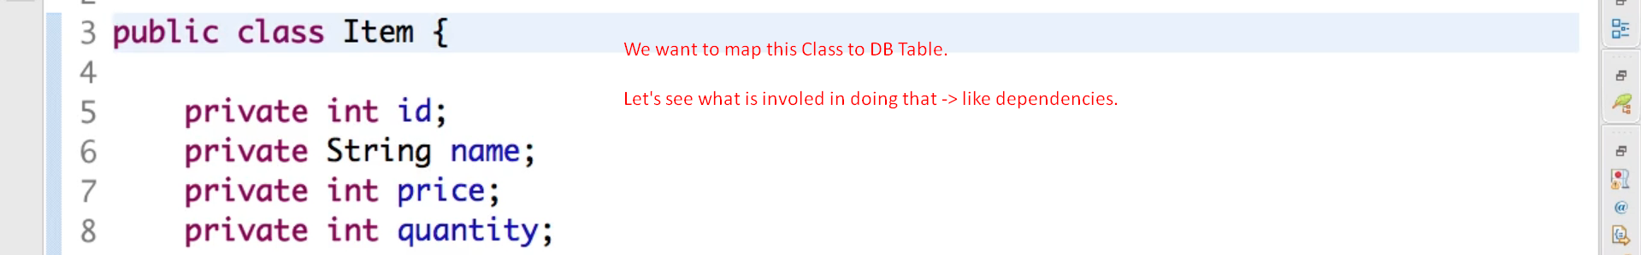
3. 
4. 
5. 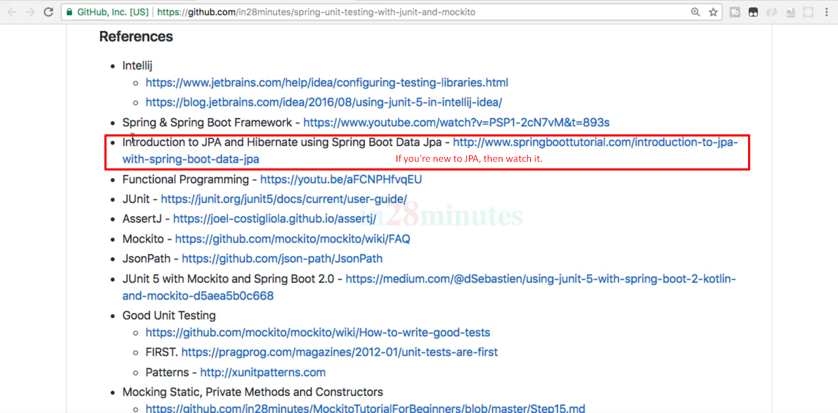
6. 